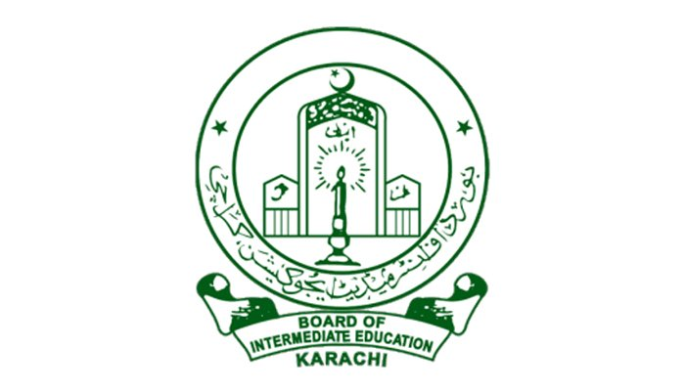

Your passport picture is here

Interboard certificate form

Original certificate will be issued only to the actual candidate

Authority letter will not be accepted

the secratery

board of intermediate education

karachi.

Sir,it is requested to kindly issue my original certificate as per details given below:

ROLL NO. YEAR.

SUPPLEMENTERY

AA

ENROLL/REG NO. ENR./YEAR